**Task-4**

# **By Group-6**

Abhinay Samala, Ankush Choudhary, Chhavi Nath, Devid, Disha Shakyawal, Pasupulati Madhulatha, Parikshit Ramchandra Sahu, Supriya

***(a) Explore the evidences of participation of India in the IC value chain.***

1. **Market Growth:** India's semiconductor consumption is expected to grow significantly. By 2026, it is projected to reach $64 billion, tripling from $22 billion in 2019. This growth is expected to continue, nearly doubling again to $110 billion by 2030. This trajectory indicates a compound annual growth rate (CAGR) of 16% over the period from 2019 to 2030.

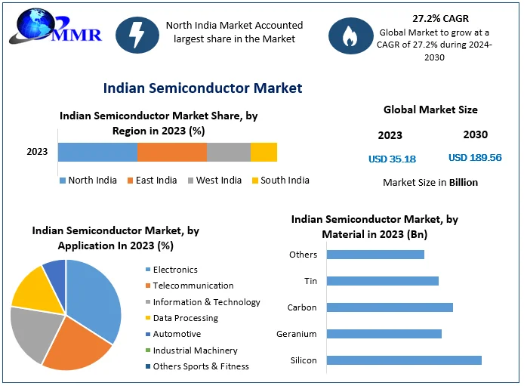  
Figure: 1 Indian Semiconductor market

1. **Sector Breakdown:** The largest components driving India's semiconductor demand by 2030 are predicted to be wireless communications ($26.5 billion), consumer goods ($26 billion), and automotive ($22 billion). This reflects India's expanding electronics production, particularly in mobile phones, and its emergence as a significant market for automotive electronics and electric vehicles.

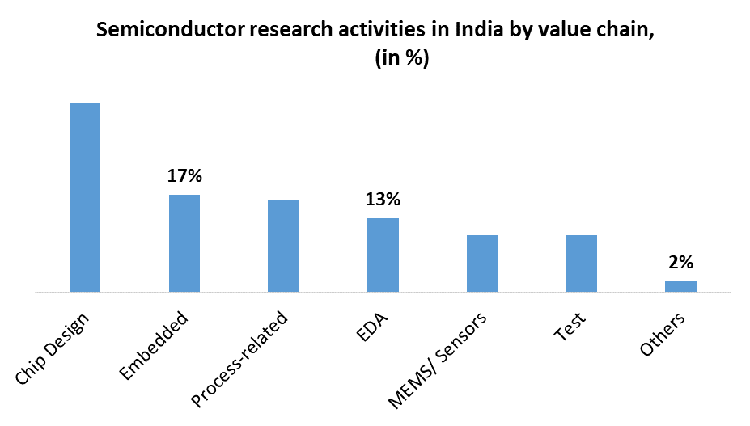

Figure 2: Semiconductor research Activities in India by Value Chain

1. **Local Sourcing Goals:** India aims to increase its local sourcing of semiconductors from 9% in 2021 to 17% by 2026. This initiative is expected to substantially boost locally sourced semiconductor revenue, aligning with broader economic goals to enhance self-sufficiency in high-tech manufacturing.
2. **Economic and Demographic Drivers:** India's overall economic growth, anticipated to make it the world's third-largest economy by 2027, alongside demographic factors such as a growing middle class and rising disposable incomes, are key drivers of increased semiconductor consumption. The expanding consumer market, particularly in electronics and telecommunications, further reinforces this demand.
3. **Global Supply Chain Dynamics:** Amid global geopolitical shifts and supply chain diversification strategies (e.g., "China-plus-one"), India stands to benefit as a favorable location for semiconductor manufacturing and assembly. Companies like Apple and Google are already shifting production to India to mitigate risks and leverage its competitive labor costs and skilled workforce.

The chip fabrication unit of Tata-Powerchip at Dholera, and the CG Power-Renesas outsourced assembly and test facility at Sanand (Gujarat), along with Tata's OSAT unit at Morigaon (Assam) has been inaugurated this year in February.

1. **Investment and Export Growth:** Increased foreign direct investment (FDI) into India's manufacturing sector, coupled with rising exports of intermediate goods and electronics, underscores growing confidence in India's capabilities as a manufacturing hub. This trend is bolstered by government incentives aimed at attracting high-tech investments.
2. **Design Capabilities:** Indian companies are increasingly engaged in semiconductor design. This includes both hardware and software aspects, ranging from ASIC (Application-Specific Integrated Circuit) design to SoC (System on Chip) development. Companies like LTSCT are exemplifying this trend through partnerships aimed at developing indigenous IP SoCs.

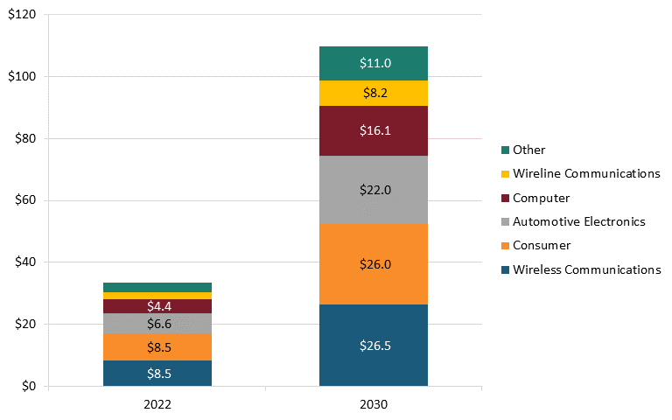

Figure 3: India’s semiconductor market, 2022 (actual) and 2030 forecast ($billions)

1. **Research & Development:** There is a growing emphasis on R&D in semiconductor technologies within India. Academic institutions, research labs, and industry collaborations are focusing on advancing semiconductor capabilities, enhancing local innovation in IC design and manufacturing.
2. **Government Initiatives:** The Government of India, through agencies like MeitY, has been actively promoting initiatives such as Make in India and Design in India. These initiatives aim to strengthen the domestic semiconductor ecosystem, reduce dependence on imports, and foster self-reliance in critical technologies.
3. **Global Collaborations**: Indian semiconductor companies are forging strategic partnerships with global leaders. Collaborations like the one between CP PLUS and LTSCT exemplify efforts to integrate global expertise with local capabilities to develop cutting-edge semiconductor products.

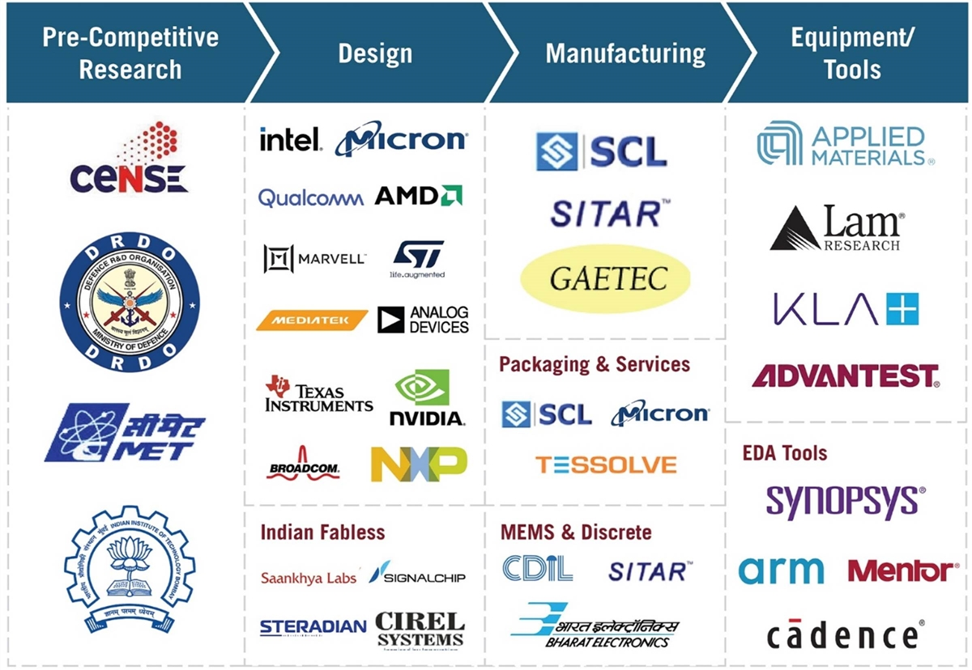

Figure 4 : Key actors in India’s semiconductor ecosystem

***(b) Prepare a report explaining LTSCT Objectives and Scope with your understanding:***

LTSCT (L&T Semiconductor Technologies) is a key player in India's semiconductor ecosystem, focusing on advanced technology solutions and semiconductor development. The objectives and scope of LTSCT include:

### **Objectives of L&T Semiconductor Technologies Limited (LTSCT)**

1. **Building India's First Semiconductor Product Company**:
   * **Goal**: Establish LTSCT as a leader in global innovation within the semiconductor industry.
   * **Focus**: Strategic sectors with fragmented markets where innovation is diverse and not geometry-driven.
2. **Global Footprint Expansion**:
   * **Presence**: Initial setups in Austin, Munich, Tokyo, Bangalore, and Chennai to leverage global talent and market opportunities.
   * **Offerings**: Energy-efficient, high-performance semiconductor solutions for data, electrification, and software-defined technology trends.
3. **Product and Solutions Strategy**:
   * **End-to-End Solutions**: Providing a complete range of semiconductor devices from sensors and MEMS to power management and central compute units.
   * **Technological Differentiation**: Emphasizing programmable peripherals, MEMs integration with SoC, and low-power scalable processor cores.
4. **Serving Strategic Business Verticals**:
   * **Energy**: Solutions for generation, transmission, and distribution, focusing on smart power and energy management.
   * **Industrial**: Automation and control systems, building automation, and surveillance and asset tracking.
   * **Mobility**: Vehicle safety, experience, and propulsion with a focus on electric and hybrid vehicles, infotainment, and ADAS.
5. **Partner Ecosystem**:
   * **Collaboration**: Engaging with foundries, OSAT (Outsourced Semiconductor Assembly and Test), and packaging partners to enhance production capabilities.
   * **Lifecycle Management**: From new product proposals to production and delivery, ensuring compliance and certification at every stage.

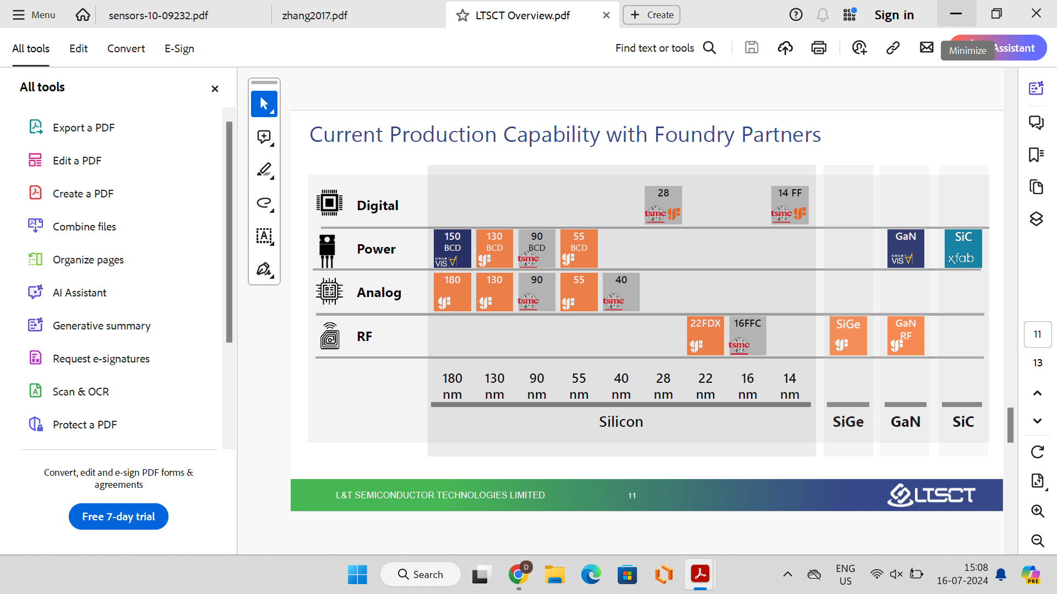

Figure 5: Current Production Capability of LTSCT with Foundry Partnership

### **Scope of L&T Semiconductor Technologies Limited (LTSCT)**

1. **Global Reach**:
   * **Offices and R&D Centers**: Established in key global locations including Austin, Munich, Tokyo, Bangalore, and Chennai.
   * **Customer Base**: Serving global customers with a focus on energy, industrial, and mobility sectors.
2. **Product Categories**:
   * **Power Products**: Power management, power sensors, analog RF, and various semiconductor devices.
   * **Smart Devices**: Development of smart, low-power semiconductor devices for innovative systems.
3. **Strategic Focus**:
   * **Energy Solutions**: Comprehensive solutions for energy generation, transmission, and distribution.
   * **Industrial Solutions**: Factory and building automation, surveillance, and asset management.
   * **Mobility Solutions**: Enhancing vehicle safety, experience, and propulsion with advanced semiconductor technology.
4. **Technology and Innovation**:
   * **In-house Fab Roadmap**: Planning and development of in-house fabrication capabilities with a timeline from pilot line to full production by 2030.
   * **Differentiating Technologies**: Emphasis on smart, low-power, and scalable semiconductor technologies.
5. **Comprehensive Product Lifecycle**:
   * **Design to Delivery**: From specification to architecture, emulation, tape-out, validation, and production.
   * **Partner Ecosystem**: Collaborating with key industry partners to enhance design, verification, and production processes. LTSCT collaborates with industry leaders like CP PLUS to combine market insights with technological capabilities, aiming to deliver innovative, locally manufactured semiconductor products.

In summary, L&T Semiconductor Technologies Limited aims to be a global leader in semiconductor innovation by leveraging strategic focus areas, global presence, and comprehensive product and solutions strategies. The company’s objectives are to build a robust ecosystem for semiconductor development, cater to various strategic business verticals, and establish in-house fabrication capabilities to support its growth and innovation roadmap.

References:

<https://economictimes.indiatimes.com/news/india/pm-modi-lays-foundation-stone-of-indias-first-commercial-semiconductor-fabrication-facility/articleshow/108453700.cms?from=mdr>

<https://www.linkedin.com/pulse/cp-plus-signs-master-collaboration-agreement-lt-semiconductor-c0spc?utm_source=share&utm_medium=member_android&utm_campaign=share_via>

<https://itif.org/publications/2024/02/14/india-semiconductor-readiness/>

<https://www.thehindu.com/sci-tech/technology/qualcomm-expands-its-chip-design-facility-in-chennai-with-a-focus-on-developing-next-gen-wifi-technologies/article67950527.ece>